Gretel.ai Quick Start

Gretel provides a set of open source APIs for synthetic data generation. Some common use cases are:

* Improve limited datasets with synthetic data
* Create synthetic data with privacy guarantees
* Generate anonymized data for testing environments
* Balancing unbalanced datasets

## Getting Started

Sign up at <https://gretel.ai/> with your google or github login. No payment info is required.

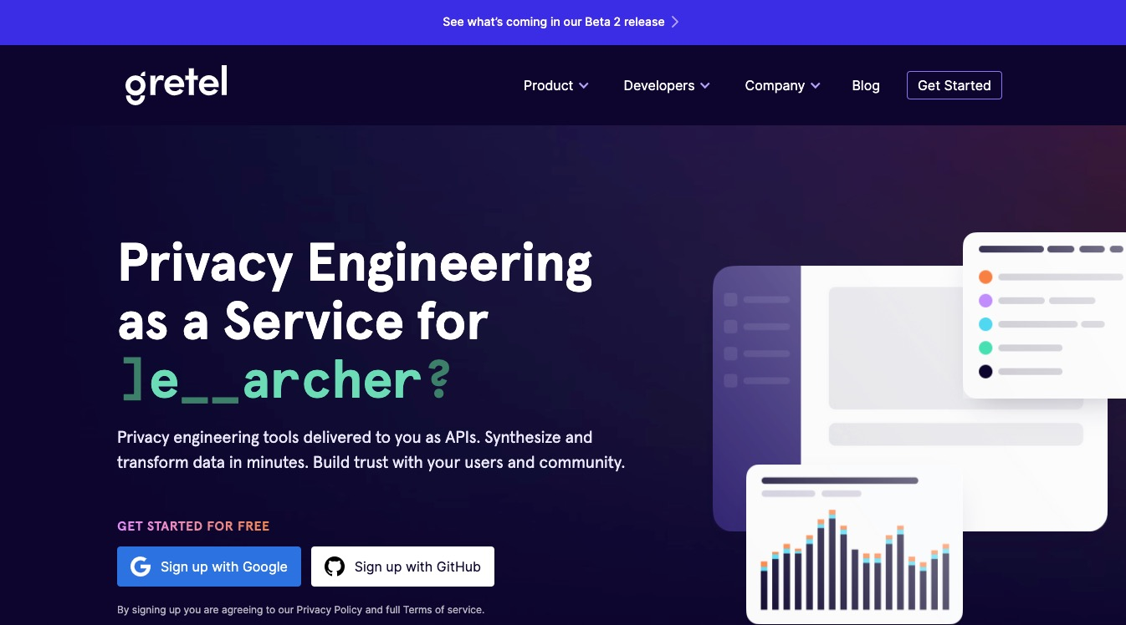

Once you’ve signed up, click the blue **New Project** button on the **Dashboard** to create a new project

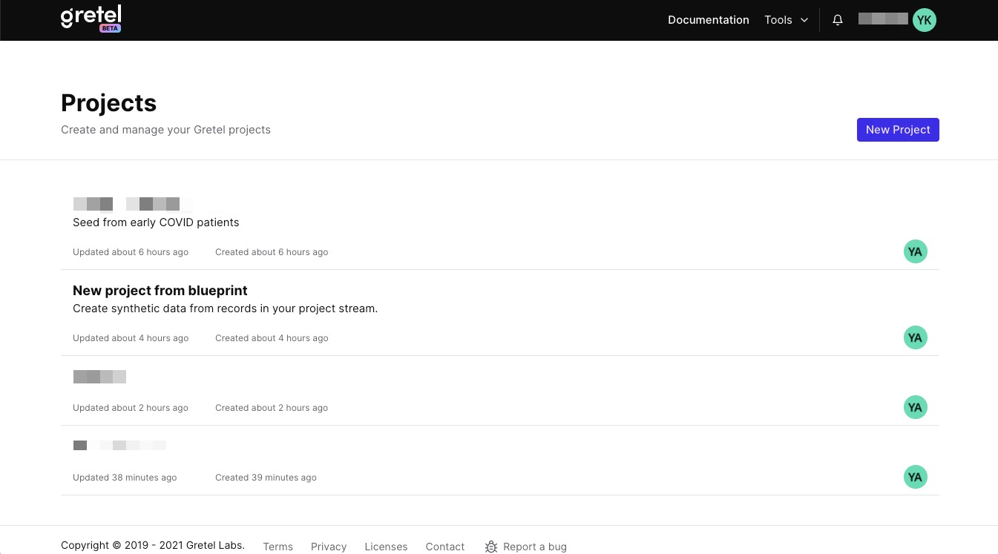

If you want to explore some boilerplate notebooks and example datasets, select **From Blueprint**. Otherwise, click **Blank Project.**

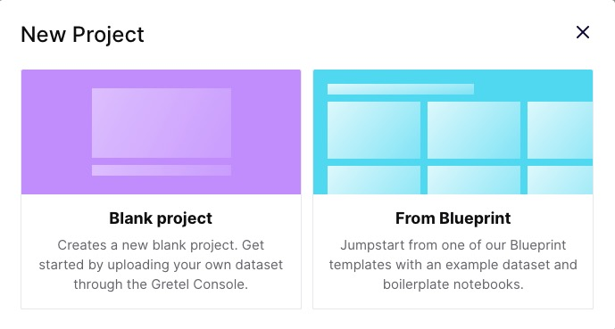

Enter the project name and description, and upload your test dataset.

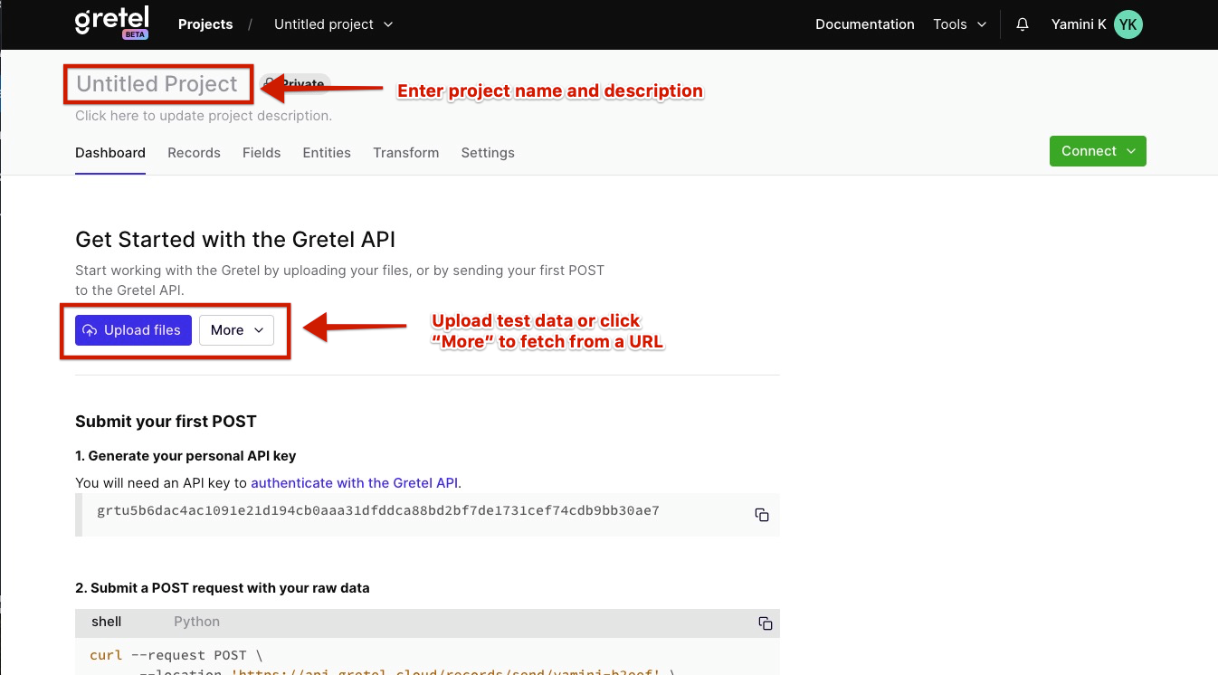

NOTE: Datasets larger than 5000 records tend to timeout. The interface just fails during the process (at least in Chrome on macOS.) The gretel documentation makes no reference to limits. Importing from a URL requires CORS to be enabled and does not seem to work well either.

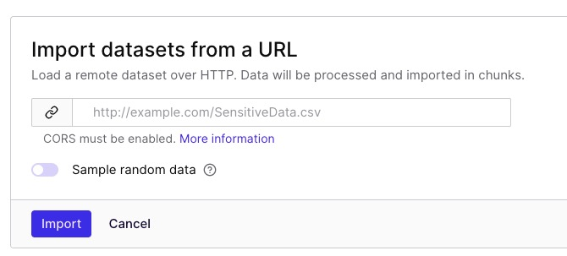

Once the test data has been uploaded, use the **Records**, **Fields** and **Entities** tabs to explore it and view labels, potential data sensitivity, distribution etc.





## Training the model

Next, it’s time to create and train the model. Click the **Transform** tab and click **Launch** in the **Create synthetic data** card

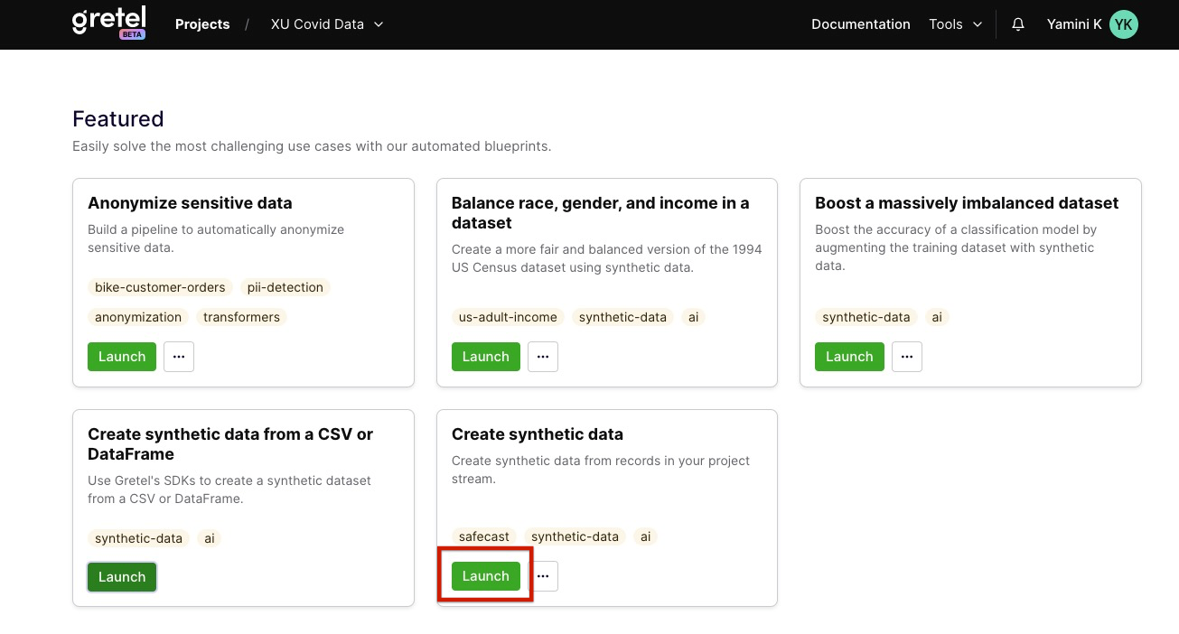

This will launch a Google Colab notebook blueprint. Save a copy to your own Google drive or download the notebook to use in your own Jupyter notebook environment.

Configure the num_lines parameter to generate 1000 records (optional, for efficiency)

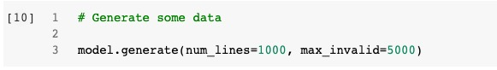

Make sure you’re using GPU, then connect to a hosted runtime and run all the commands.

Once the packages are installed, you will be prompted to enter your Gretel URI.

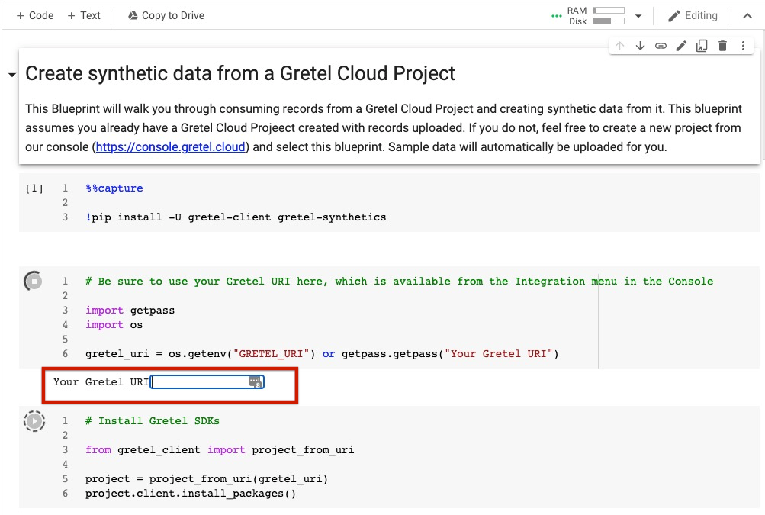

Go back to your project in gretel.ai. Click the green **Connect** button in the top right, and copy the **Project URI**



Paste the URI into the notebook and hit Enter.

The notebook can take around 20 minutes to run, longer depending on the size of the training data. Once it’s done, it will generate a training dataframe, a model, the synthetic data, and a report that analyzes the results. Here’s a report example:

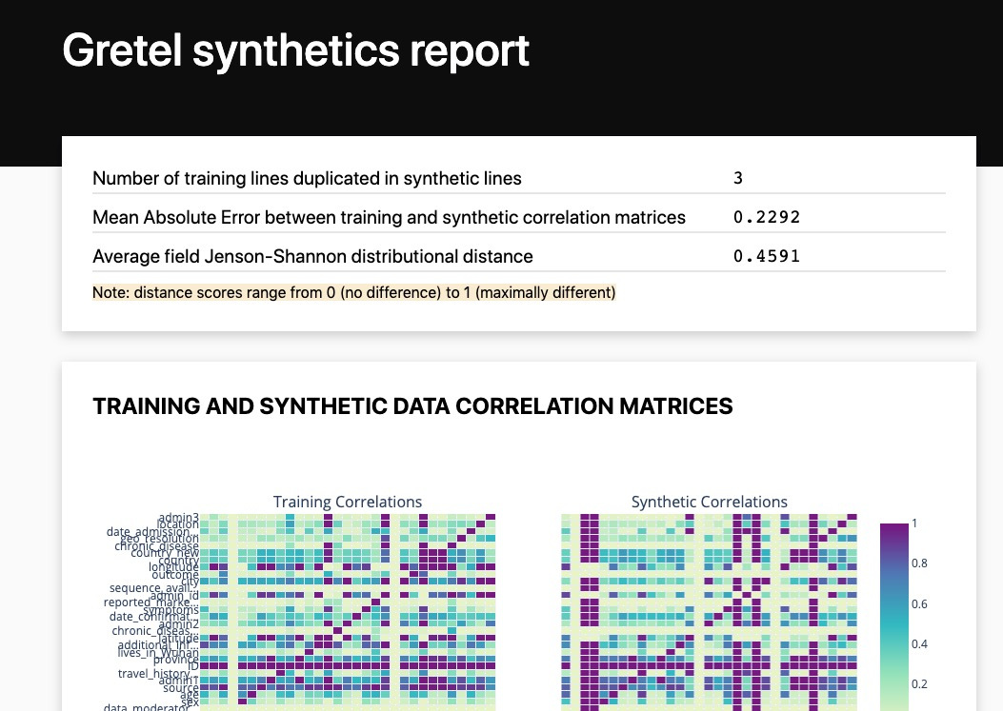

The report and the model can be downloaded locally.

## Using the model to create synthetic data

## Auto-balancing data

Creating a balanced version of a dataset

## Validating the model and output data

## Appendix

* [Gretel API Docs](https://gretel-client.readthedocs.io/en/latest/)
* [Gretel documentation and video guides](https://gretel.ai/docs)
* [Gretel github repo](https://github.com/gretelai)
* [Gretel Slack group](https://gretel.ai/slackinvite)
* [DataKind Data Dive source data](https://drive.google.com/drive/folders/1aMF85IgX8r13C5zeHvkc3xGJ04OAV9Ck)
* [Volunteer generated data](https://drive.google.com/drive/folders/1utgNLW-Q5DgLCVQQFtlMOhlIOWRFS4_w)